Progress Note

|  |  |  |
| --- | --- | --- |
| Date: Feb 7th | Start Time: 16:00 | End Time: 16:51 |
| Type of Contact: In person | Members Present: The Walker Family (Randy, Elizabeth, Matthew, and Faith) | | |

Assessment results: Randy General Functioning score: 4; Elizabeth General Functioning score: 3.84

Summary: The purpose of today’s section was to understand the overall family function. I introduced the Family Assessment Device (FAD; Please see the Appendix C) for the Walker family by telling them that the device could help identify the central problem of the family function. I assumed the FAD helped understand their perception of role and responsibility and evaluate their family strength and weakness through six dimensions (problems solving, communication, roles, affective responsiveness, affective involvement, behavioral control, general functioning). The couples did the FAD (Family Assessment Device) individually, then I provided feedback to the family. I asked about their feeling about their FAD results, Elizabeth said she didn’t feel the score can represent the family’s function. I assume the family member did not consider the whole family function but individual or subgroup function when they did the assessment. The reason was Randy’s god problem-solving score based on his ability of self-caring. When I asked for the ideas, they had the problem. Communication score was also high for, which cannot show the dysfunction of the family either. Elizabeth explained she felt she expressed her emotion all the time and talked to Randy actively to solve the problem. Hypothetically, the couples need to take some Communication course to understand that their complaint and ignorance were not a positive communication. The primary finding was not the interpretation of the result, but the negative interaction pattern, such as laying the blame on each other. The Walker family agreed there was something need to be changed, but neither of them would like to take the first move. Briefly, the scores of the Walker family’s FADS could only show how the individual felt and subjective perception; however, it could not represent the entire function of the family. I assume the problem of the Walker family was their negative interaction. I plan to work with the family to develop their primary goal and possible solution for some of their issues in next meeting.

Plan: Goal setting and treatment planning

Signature_____________________________________________________________________

Appendix C

The Walker family’s functional assessment device

|  |  |  |  |  |  |  |  |
| --- | --- | --- | --- | --- | --- | --- | --- |
|  | Problem Solving | Communication | Roles | Affective Responsive | Affective Involvement | Behavioral Control | General Functioning |
| Randy | 3.6 | 2.28 | 3.3 | 3.2 | 2.37 | 3.4 | 4 |
| Elizabeth | 4 | 2 | 3.8 | 3 | 3 | 3.2 | 3.84 |
|  |  |  |  |  |  |  |  |

Part 1:

Part 2: Elizabeth’ FAD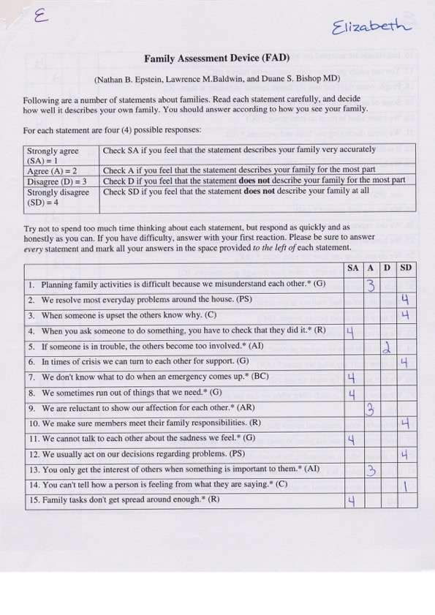

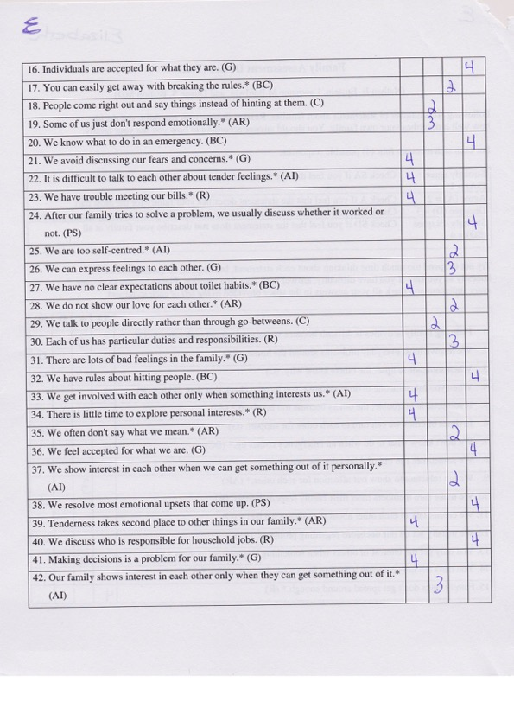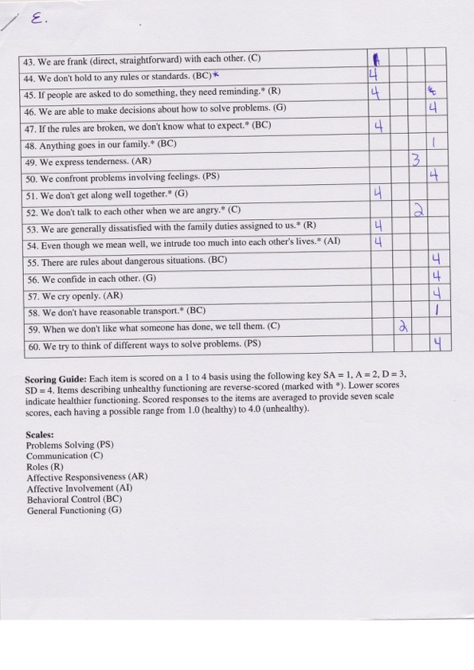

Part 2: Randy’s FAD

